WazuGuardix Internship 

Prepared By: Muhammad Safwan
Date: 23rd November 2025

A Practical SOC Internship Program Covering Wazuh

Purpose:
To empower students with hands-on experience in SOC operations, threat detection, and automation using Wazuh and integrated tools, preparing them for real-world cybersecurity challenges.
Scope:

This training focuses on configuring and operating Wazuh for real SOC workflows. It includes setting up VirusTotal integration, verifying analysis scripts, configuring File Integrity Monitoring (FIM), and testing detection with EICAR and multiple file types (benign, suspicious, and modified files). Each task is designed to build practical skills in threat detection, malware validation, and incident response within a Wazuh environment.
Audience:
Ideal for students, SOC Students, and cybersecurity enthusiasts looking to build a strong technical foundation and gain practical skills in security monitoring and automation.

Wazuh With VirusTotal Integration

Advanced SIEM & Threat Intelligence Integration Project

Task Overview

Objective:
Deploy and configure a functional Wazuh-VirusTotal integration environment to detect, analyze, and respond to security threats in real-time.

Phase 1: Environment Setup

This initial phase is the foundation of the Security Operations Center (SOC) lab environment. The primary objective is to establish a working, multi-node Wazuh deployment capable of centralized security monitoring.

Task 1.1: Wazuh Manager Installation

This task focuses on deploying the core analytics engine—the Wazuh Manager—on the designated security server (Kali Linux). The Manager is the central brain responsible for processing, analyzing, correlating, and storing all security data received from endpoint agents. This includes:

- Establish the Platform: Successfully install all required Wazuh components.
- Verify Health: Ensure all necessary Wazuh services are running correctly.
- Access the UI: Confirm access to the Wazuh Dashboard (using the OpenSearch/Kibana interface) to ensure the system is ready to visualize security data.

The screenshot below shows the Wazuh web login page (large Wazuh branded splash) with admin username populated and a password entered. Browser address bar shows https://X.X.X.X/ (the Wazuh host IP used in deployment).

This confirms the Dashboard is reachable and the web interface was installed and presented for authentication.

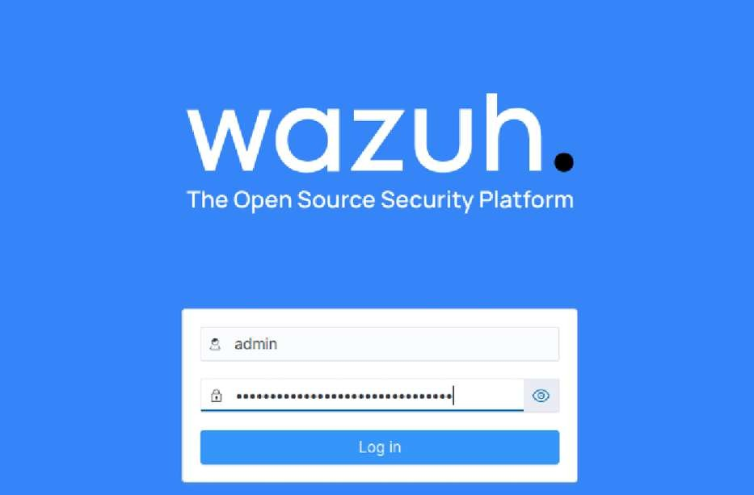
Below that is a screenshot of the Wazuh Dashboard overview page showing an “AGENTS SUMMARY” panel that reads “This instance has no agents registered” and a prominent Deploy new agent button, it confirms dashboard service is running and accessible, and that no agents were yet registered now of the screenshot.
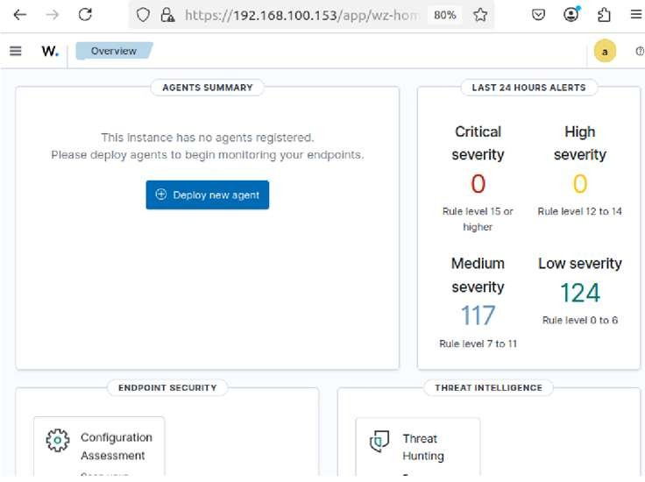

Task 1.2: Agent Deployment

This task focuses on extending the monitoring capability to a target endpoint (the Ubuntu machine). The Wazuh Agent is lightweight software installed on the monitored system, responsible for local data collection (logs, file integrity changes, configuration information etc) and secure transmission back to the Manager. This includes:

- Endpoint Installation: Install the Wazuh agent package on the Ubuntu endpoint.
- Secure Enrollment: Configure the agent's connection settings (pointing to the Manager's IP) and enroll the agent securely.
- Verify Connectivity: Confirm the agent is actively reporting data and is visible within the Wazuh Dashboard's list of connected agents.

Below Shows the Wazuh “Deploy new agent” UI with platform options: Linux, Windows, macOS and radio buttons for package types (DEB/RPM, MSI, etc.).

The UI is clearly set to choose Linux DEB (DEB amd64 selected) as an installation package. This screen is the Dashboard-based registration/installation step and directly corresponds to the Agent Deployment. Displays the Deploy-agent form area titled Server address: with an assigned server address filled in as X.X.X.X (Wazuh manager IP) and an option to remember it.

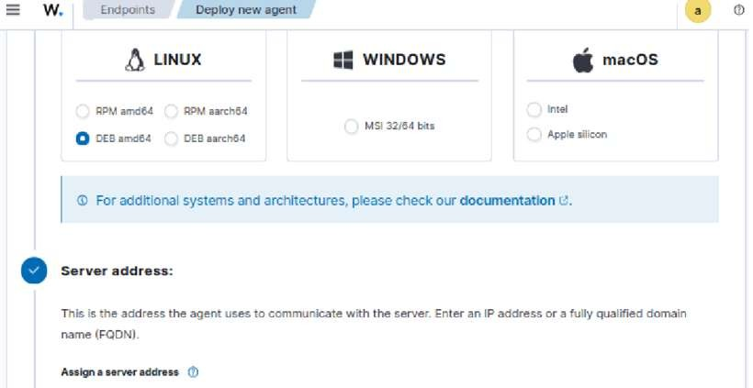

Before accessing the endpoint terminal, I prepared the deployment parameters within the Wazuh interface. I opted to define a specific, unique name for the agent rather than using the default hostname. I assigned the name ubuntu-agent to ensure it could be easily identified within my environment.

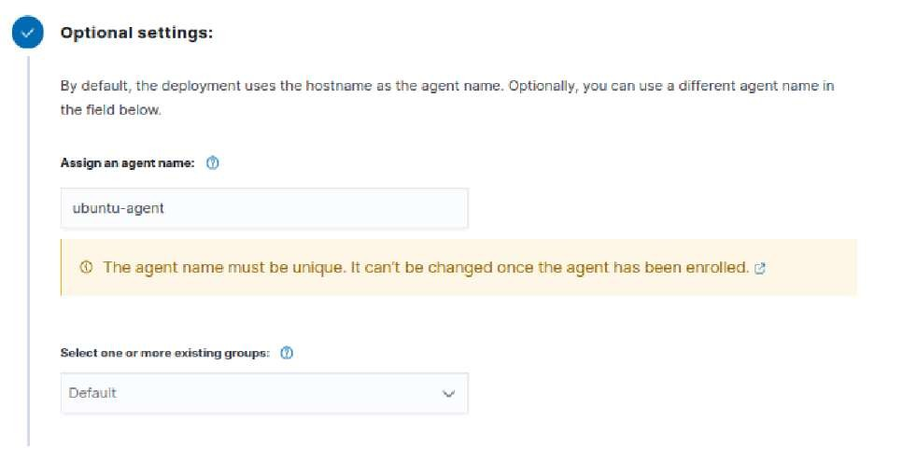

Next, on the target Ubuntu machine, I downloaded the specific Wazuh agent Debian package using wget. I then executed the installation using dpkg. During this single command step, I simultaneously configured the agent to communicate with my manager by passing necessary environment variables.

wget https://packages.wazuh.com/4.x/apt/pool/main/w/wazuh-agent/wazuh-agent_4.13.11_amd64.deb

This command initiated the download of the Wazuh agent Debian package (.deb file) from the official Wazuh package repository directly onto the Ubuntu machine. wget is a non-interactive network downloader used for retrieving files from the internet.

WAZUH_MANAGER='X.X.X.X' WAZUH_AGENT_NAME='ubuntu-agent' dpkg -i ./wazuh-agent_4.13.11_amd64.deb

This command performed the installation of the downloaded .deb package and simultaneously configured the agent to connect to my Wazuh Manager.

- WAZUH_MANAGER='X.X.X.X': This sets an environment variable specifically for this command execution, telling the installing agent that the Wazuh Manager is located at the IP address X.X.X.X.
- WAZUH_AGENT_NAME='ubuntu-agent': Similarly, this sets an environment variable defining the unique name for this agent, ubuntu-agent, during its installation.
- dpkg -i ./wazuh-agent_4.13.1-1_amd64.deb: dpkg is the package manager for Debian-based systems. The -i option stands for "install," instructing dpkg to install the specified package file located in the current directory (./). This command unpacks the software, places files in the correct locations, and executes post-installation scripts that utilize the WAZUH_MANAGER and WAZUH_AGENT_NAME variables for initial configuration.

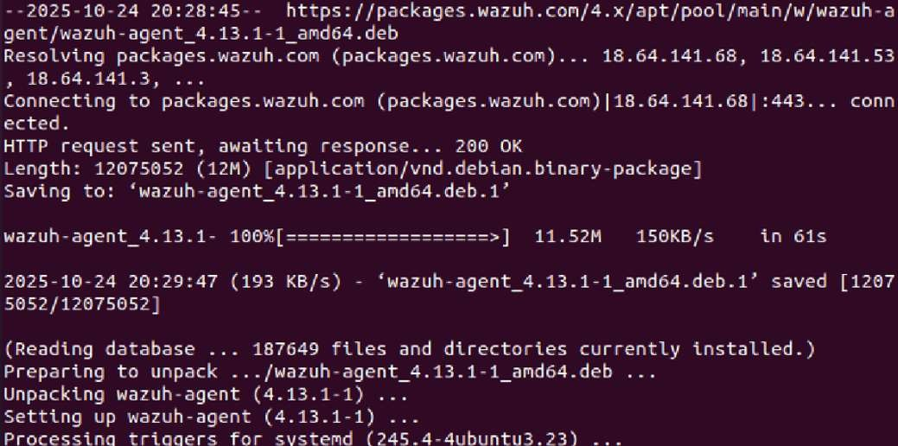

Once the installation was completed successfully, I needed to activate and manage the agent service on the Ubuntu endpoint.
Here's an explanation of the systemctl commands I used:

- sudo systemctl daemon-reload
  - Purpose: After installing new system services (like wazuh-agent), systemd (the init system used by modern Linux distributions like Ubuntu) needs to be informed about them. This command reloads the systemd manager configuration, ensuring it recognizes the newly installed wazuh-agent.service unit file. sudo is used to execute command with root privileges.

- sudo systemctl enable wazuh-agent
  - Purpose: This command creates a symbolic link that ensures the wazuh-agent service will automatically start whenever the system boots up. The output Created symlink ...
confirms this action. enable makes the service persistent across reboots.

- sudo systemctl start wazuh-agent
  - Purpose: This command immediately starts the wazuh-agent service for the current session. This allows the agent to begin its operations and attempt to connect to the Wazuh Manager without requiring a system reboot.

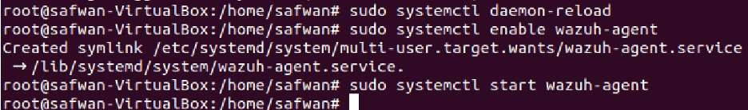

Finally, to confirm the successful deployment and enrollment, I accessed the terminal on the Wazuh Manager server and used its agent control utility.

- sudo /var/ossec/bin/agent_control -l
  - Purpose: This command is executed on the Wazuh Manager.
/var/ossec/bin/agent_control is the utility used to manage and monitor connected agents. The -l flag (for "list") instructs the utility to display a list of all agents currently managed by the Wazuh Manager, along with their IDs, names, IP addresses, and operational status. This allowed me to verify that the new agent, ID 001 named ubuntu-agent, was listed with an "Active" status, confirming it is successfully communicating with the manager.

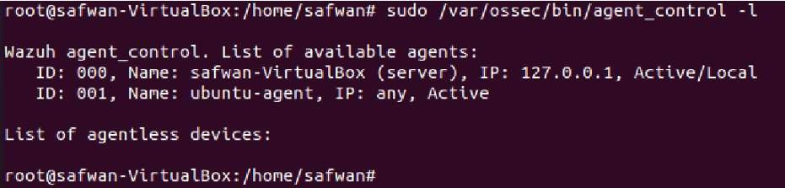

Phase 2: VirusTotal Integration

This phase is dedicated to integrating external threat intelligence into the Wazuh Manager. The goal is to automatically enrich alerts related to file creation and modification by checking file hashes against the massive, curated database of known malware on VirusTotal. This transforms a simple "file created" alert into a high-confidence security incident if the file is malicious.

Task 2.1: API Configuration

Objective: This task focuses on securely establishing the communication link between the Wazuh Manager and the VirusTotal API.
The Wazuh Manager's central configuration file (ossec.conf) must be modified to include the VirusTotal integration block, specifying the unique API key and directing Wazuh to submit hashes for all FIMrelated alerts (<group>syscheck</group>). Post-configuration, the Wazuh service is restarted to load the new settings, and its status is verified to ensure the integration was initialized without generating service failures.

Here, you can see the initial and very important step I took obtaining my personal VirusTotal API key. This screenshot shows the VirusTotal platform where I retrieved this unique identifier. This key is crucial because it allows my security system to securely connect and interact with VirusTotal's vast database of threat intelligence.

- API Key: This is my personal and confidential key, which I made sure to handle with care as per the warnings about not disclosing it.
- Purpose: I obtained this to ensure my system could securely authenticate itself when sending queries to VirusTotal.
- Functionality Enabled: With this key, I can now submit things like file hashes, IP addresses, and URLs to VirusTotal to check against their global threat intelligence.

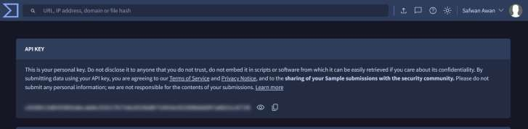

This screenshot demonstrates how I configured the ossec.conf file, which is the core configuration file for my Wazuh manager. I meticulously added the necessary XML block to integrate VirusTotal into my security monitoring.

- Integration Block: I inserted this specific <integration> section into ossec.conf to define how Wazuh should interact with VirusTotal.
- VirusTotal Name: I explicitly named the integration virustotal, so Wazuh knows exactly which service it's dealing with.
- API Key Insertion: Crucially, I placed my API key (obtained from the previous step) within the <api_key> tags. This is how Wazuh will authenticate its requests to VirusTotal.
- Syscheck Group: I assigned this integration to the syscheck group, which means that file integrity monitoring events can now trigger automatic VirusTotal lookups – a powerful way to enhance detection.
- JSON Alert Format: I specified json for the <alert_format>, ensuring that any alerts generated from this integration will be in a standardized, machine-readable format for easier processing and analysis.
- My Goal: By doing this, I've successfully bridged my local Wazuh manager with VirusTotal's global threat intelligence, significantly enhancing my system's ability to identify and respond to threats.

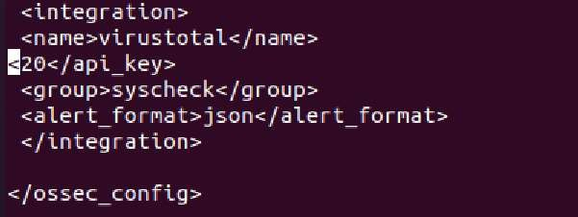

After inserting the API key and setting file permissions, I ran sudo systemctl status wazuh-manager. This output confirms the Wazuh manager successfully restarted and is Active (running). This verifies that the new integration, along with the VirusTotal API key, was initialized correctly without generating any service errors.

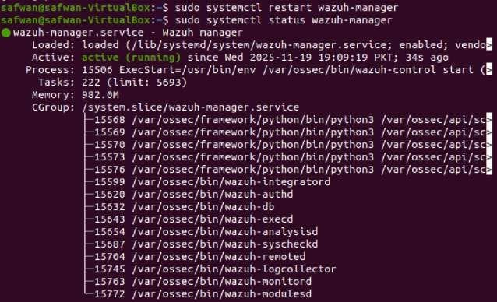

Task 2.2: Script Verification

Objective: This task verifies the security and integrity of the necessary integration script before active use.
To prevent unauthorized access or tampering, the VirusTotal integration script (virustotal.py) must be verified to confirm it resides in the correct directory (/var/ossec/integrations/) and adheres to strict permission standards. Applying the root:wazuh ownership and 750 permissions guarantees that the script is executable only by the required security service and cannot be modified by low-privilege users.

This screenshot confirms that I successfully navigated to the /var/ossec/integrations/ directory and verified the presence of the necessary virustotal.py script. By running the ls command, I could see all the integration scripts, and I've highlighted virustotal.py to show its existence clearly. This step was crucial to ensure that the script responsible for handling the VirusTotal API calls was indeed in the correct location, ready for execution by Wazuh.

- Location: I confirmed I was in the /var/ossec/integrations/ directory.
- ls command: I used this command to list the contents of the directory.
- virustotal.py: I visually verified that the Python script for VirusTotal integration was present.
- Importance: This step ensures the core execution file for the integration exists in the expected path.

After confirming the script's presence, this screenshot demonstrates how I applied the correct permissions and ownership to the virustotal.py script. I used the ls -la virustotal command to display the detailed file attributes, ensuring everything was set up securely and correctly for Wazuh to execute it.
- ls -la virustotal: I ran this command to view the detailed permissions, ownership, and other attributes of the virustotal (which likely refers to virustotal.py in the context, as the output shows its permissions).

- Permissions (-rwxr-x--- or 750): I specifically set these permissions.
  - rwx (read, write, execute) for the owner (root).
  - r-x (read, execute) for the group (wazuh).
  - --- (no permissions) for others.
  - This translates to 750 numerically, which is secure yet allows Wazuh to execute the script.

- Ownership (root:wazuh): I ensured the file was owned by the root user and the wazuh group. ➢ root as the owner provides administrative control.
  - wazuh as the group allows the Wazuh service (which typically runs as the wazuh user or within the wazuh group context) to execute the script effectively.

- Importance: Setting these permissions and ownership correctly is vital for both security (preventing unauthorized access/modification) and functionality (allowing the Wazuh manager to properly execute the script).

Phase 3: File Integrity Monitoring

This phase establishes the foundational capability for host-based intrusion detection by configuring File Integrity Monitoring (FIM) on the monitored endpoint. FIM is crucial for detecting unauthorized file creations, deletions, or modifications, which are often key indicators of malicious activity or policy violations.

Task 3.1: Configure FIM

Objective: To establish real-time surveillance over a specific, user-defined file path on the monitored endpoint.
The Wazuh Manager's configuration is updated to include the <directories> setting, which specifies the target path (/home/[username]/test_monitored). By enabling the realtime="yes" and check_all="yes" attributes, the system is configured to monitor file creation, deletion, and content modification instantly. This action officially designates the file path as a protected asset, ensuring continuous integrity verification by the Wazuh agent.

First, I created the target directory to be monitored by FIM. The specific directory used for testing was /home/safwan/FIM, as verified by the pwd command.
Next, I modified the /var/ossec/etc/ossec.conf file. I added a new <directories> block under the FIM settings to ensure this directory was actively monitored, as shown in the configuration snippet. The settings were applied as follows:
- Path: <directories check_all="yes" report_changes="yes" realtime = "yes" > /home/safwan/FIM </directories>
- Mode: I set check_all="yes" to perform all possible verifications and realtime="yes" to ensure immediate alerting upon any file changes (creation, modification, or deletion).

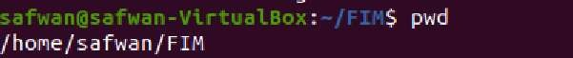

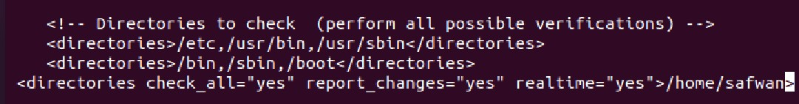

After saving the configuration, I restarted the Wazuh manager using sudo systemctl restart wazuhmanager. The manager successfully initialized, applying the new FIM configuration.

Task 3.2: Test with EICAR File

Objective: To execute an end-to-end test that confirms the seamless integration of FIM detection and VirusTotal Threat Intelligence enrichment.
By introducing the EICAR test string into the monitored directory, this task proves the full security pipeline is functional:
- Detection: FIM immediately detects the creation of the potentially malicious file.
- Analysis: The file's hash is automatically submitted to VirusTotal (as configured in Phase 2).
- Alerting: The Wazuh Manager correlates the information and generates a high-severity alert, confirming the file as malicious.

In this first screenshot, I'm initiating the process to create an EICAR test file within a directory monitored by Wazuh. First, I used touch eicar.com to create an empty file, then ls to confirm its creation. Next, I applied to chmod 777 eicar.com to ensure there would be no permission issues preventing the Wazuh agent from reading or the EICAR content from being written. Finally, I opened eicar.com with nano to insert the EICAR test string.

- touch eicar.com: Command used to create an empty file named eicar.com.
- chmod 777 eicar.com: I set full read, write, and execute permissions for all users to ensure the file was accessible for the test, removing any potential permission-related roadblocks for the ubuntu-agent.
- nano eicar.com: Command used to open the file for editing and insert the EICAR test string.
- Purpose: This entire sequence prepares the "malicious" file that Wazuh will detect.

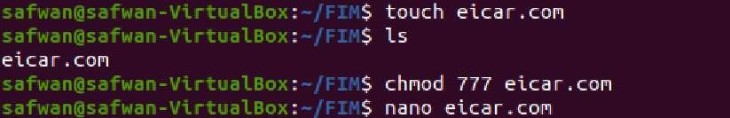

This screenshot captures the moment I inserted the official EICAR test string into the eicar.com file using the nano editor. This specific string is recognized by almost all antivirus software as a harmless yet detectable "virus" signature. The "Modified" indicator at the top right confirms that I've successfully altered the file's content.

- EICAR Test String: X5O!P%@AP[4\PZX54(P^)7CC)7}$EICAR-STANDARD-ANTIVIRUS-TESTFILE!$H+H* – This is a universally recognized string designed to trigger antivirus detection without causing actual harm.
- Significance: This step creates the "threat" that the Wazuh and VirusTotal integration is designed to detect.
•
This screenshot shows the Wazuh dashboard, providing the first visual confirmation of integration's success. I can see an alert specifically indicating "VirusTotal. Alert" for /home/safwan/FIM/eicar.com. The alert shows that the file was scanned by "58 engines," which is a clear sign that the ubuntu-agent detected the file modification, sent its hash to VirusTotal, and received a detection report.

- "VirusTotal. Alert": The prominent alert indicating successful integration and detection.
- ubuntu-agent: The agent that detected the file modification.
- /home/safwan/FIM/eicar.com: The path to the EICAR file that was detected.
- "58 engines": This number signifies that VirusTotal scanned the file with 58 different antivirus engines, confirming a comprehensive check.
- 87105 (Alert ID): A unique identifier for this specific alert, which I can use for further investigation.
- Proof: This visually confirms that the Wazuh agent detected the EICAR file and the VirusTotal integration was successfully triggered.

Delving deeper into the alert, this screenshot displays the "Document Details" within the Wazuh interface. Here, I can clearly see several key data points confirming that the VirusTotal integration was indeed active and successful. The data.integration: virustotal and data.virustotal.found: 1 are particularly important.

- agent.id: 002, agent.ip: 192.168.100.134, agent.name: ubuntu-agent: These fields identify the specific agent that reported the incident.
- data.integration: virustotal: This explicitly confirms that the alert was generated because of the VirusTotal integration.
- data.virustotal.found: 1: This crucial indicator shows that VirusTotal found the file to be malicious (or at least detected by some engines, in this case, EICAR).
- data.virustotal.malicious: 1: Further confirms that VirusTotal identified the file as malicious.
- data.virustotal.permalink: Provides a direct link to the VirusTotal analysis report for the detected file, allowing for deeper investigation.
- Verification: This detailed view definitively proves that the VirusTotal integration processed the EICAR file.

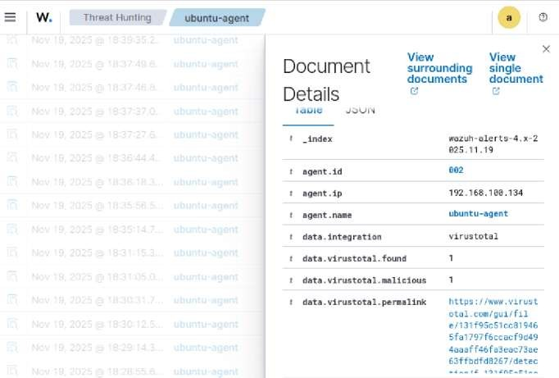

This screenshot provides more specific details from the alert, focusing on the cryptographic hash and the VirusTotal permalink. The md5 hash is essential for identifying the file, and the permalink offers a direct path to the comprehensive VirusTotal report online.

- eicar.com: The name of the file that triggered the alert.
- md5: "69630e4574ec6798239b091cda43dca0": This is the MD5 hash of the EICAR file. It's a unique fingerprint that VirusTotal uses to identify the file across its database.
- permalink: "https://www.virustotal.com/gui/file/...": This URL is a direct link to the full VirusTotal report for this specific file, providing access to all scan results and details.
- scan_date: "2025-11-19 10:17:26": Shows the timestamp when the file was scanned by VirusTotal.
- Context: These details are vital for forensic analysis and understanding the exact nature and timing of the detection.

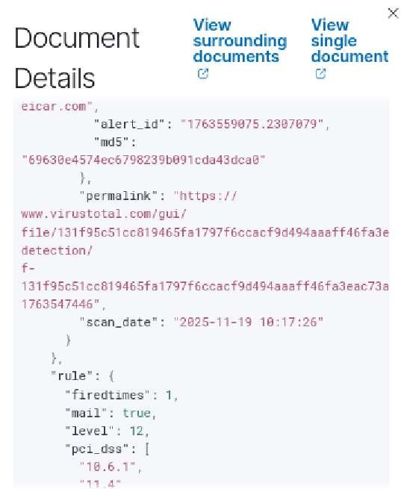

Finally, this screenshot shows the actual VirusTotal web report that corresponds to the permalink from the Wazuh alert. It visually confirms that the eicar.com was indeed submitted to and analyzed by VirusTotal. The "58/66" score indicates that a significant number of antivirus engines identified the EICAR string as a threat.

- VirusTotal Interface: The official VirusTotal website showing the scan results.
- Detection Score: "58/66" indicates that 58 out of 66 antivirus engines detected the EICAR file. This is a very high detection rate, as expected for a standard test file.
- File Hash: The hexadecimal string below the score matches the hash of our eicar.com file.
- File Name: Shows the file name (e.g., eicar.txt which is a common naming convention for EICAR files in VT).
- Ultimate Validation: This screenshot provides the ultimate proof that the entire chain, from EICAR creation to Wazuh detection, to VirusTotal query, and finally to receiving the external threat intelligence, is fully functional.

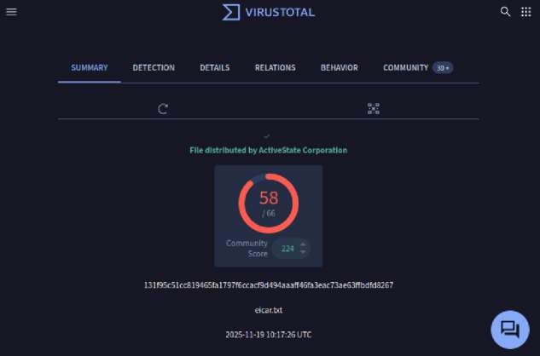

Phase 4: Advanced Testing

This final testing phase moves beyond basic function verification to rigorously assess the security system's classification accuracy and the analyst's operational ability to interpret high-priority alerts.

Task 4.1: Multiple File Types

Objective: To systematically test the Wazuh FIM and VirusTotal integration across various file integrity scenarios to ensure accurate alert generation and classification. This task simulates realistic events by testing three distinct scenarios:
- Benign File: Confirms the system correctly generates a Low Severity alert for harmless files and receives a "Not Malicious" classification from VirusTotal.

- Suspicious File: Pushes the system's logic by testing a known hash. This scenario verifies that Wazuh correctly calculates the hash of the file's content, confirming the expected failure to detect malware when the file is not the actual binary.
- Modified File: Confirms FIM's primary function by generating a Medium Severity alert solely based on the cryptographic checksum change of an existing file, which is a key indicator of tampering. Benign File:
This screenshot documents the creation of a simple, benign text file, which I named benignfile.txt, within the Wazuh-monitored directory ~/FIM. This action is crucial for testing how our integrated system reacts to non-threatening changes.
  - touch benignfile.txt: I used this command to create an empty text file, simulating a typical benign file creation.
  - ls: This command allowed me to verify that benignfile.txt was successfully created and is present in the monitored directory.
  - Purpose: This step establishes a known "good" file to observe how Wazuh and VirusTotal process it, expecting a non-malicious outcome.

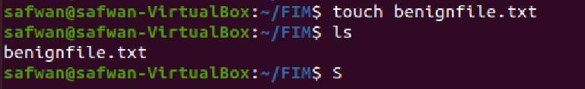

This screenshot displays the Wazuh dashboard, showing the alerts generated after benignfile.txt was created and processed. What's important here is the absence of a high-severity malicious alert, and instead, we see an informative VirusTotal alert indicating "No records."

  - File added to the system. (Rule 554): This initial alert confirms that Wazuh's FIM successfully detected the creation of benignfile.txt.

  - VirusTotal: Alert - No records in VirusTotal data... (Rule 87103): This specific alert is key. It signifies that:
    - Wazuh calculated the hash of benignfile.txt.
    - The hash was sent to VirusTotal via the integration.
    - VirusTotal's extensive database did not find any records indicating that this specific file hash is malicious. This is the expected and desired outcome for a benign file.

  - Absence of High Severity: Unlike the EICAR test, there's no high-severity alert indicating malicious activity, confirming the system's ability to differentiate.

  - Context: These alerts collectively confirm that the Wazuh agent is monitoring the directory correctly, and the VirusTotal integration is functioning as expected, providing a clear indication when a file is not recognized as a threat

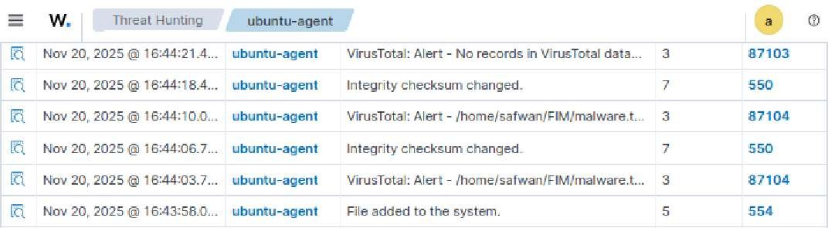

This screenshot provides the "Document Details" of the VirusTotal: Alert - No records in VirusTotal data... alert. It offers granular proof from VirusTotal that the benignfile.txt is indeed clean.

  - data.virustotal.malicious: 0: This critical field explicitly states that VirusTotal did not classify the file as malicious. The value 0 confirms its benign status.
  - data.virustotal.positives: 0: This further reinforces the benign status, indicating that zero antivirus engines on VirusTotal detected anything suspicious with this file.
  - data.virustotal.permalink: Even for benign files, VirusTotal provides a permalink. While it won't show detections, it links to the report confirming the absence of threats, demonstrating the full execution of the integration process.
  - data.virustotal.scan_date: Shows the date and time when VirusTotal scanned the hash, confirming a recent check.
  - data.virustotal.source.file: /home/safwan/FIM/benignfile.txt: Confirms that the alert relates to our benignfile.txt.
  - Validation: These details validate that our Wazuh and VirusTotal integration accurately processes benign files, avoiding false positives and correctly reporting their clean status. This is crucial for maintaining an efficient and reliable security monitoring system.
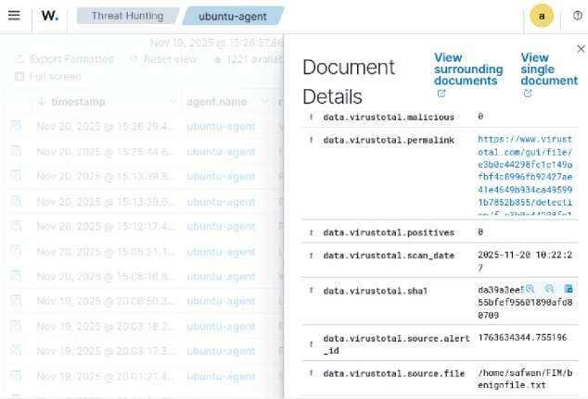
Suspicious File:
Initial Verification began by taking a known malicious hash and manually querying it on the public
VirusTotal website. This check successfully verified that the hash corresponds to a known malware file and is classified as malicious by multiple security engines.

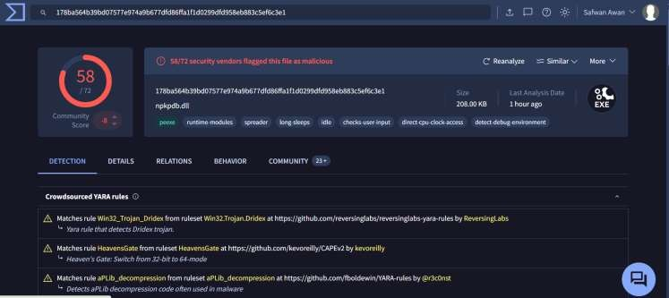

A file named knownmalware.txt was created in the monitored directory, and the text of this confirmed malicious hash was put inside it.

When Wazuh's FIM detected the new file, it calculated the hash of the file's content. Since the file's content was just a plain text string (the hash), Wazuh submitted the hash of that text file to VirusTotal. This hash did not match the hash of the original malware binary.
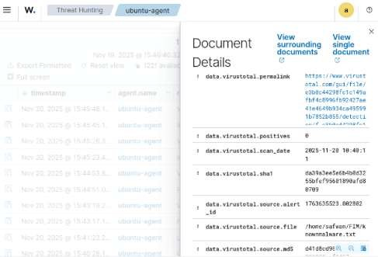
As a result, Wazuh generated a Level 3 (Low) alert with the message: "No records in VirusTotal data" (Rule 87104).
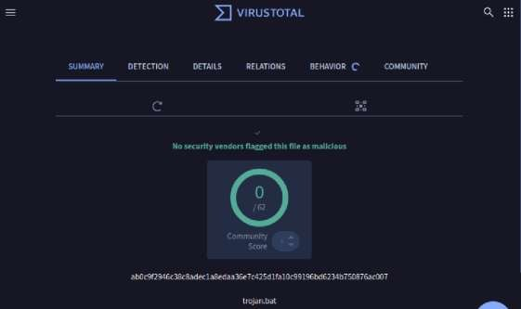

Conclusion:
This scenario highlights a crucial technical distinction: the Wazuh integration only detects if the actual file content is malicious, not if it contains a malicious hash string. The test proved FIM is working, but it confirmed that the file must be the malware binary itself for the VirusTotal integration to return a positive match.

Modified file:
The file, benignfile.txt, located in the FIM-monitored directory (/home/safwan/FIM). I then modify it by writing the simple, harmless text string: "This is benignfile.txt". When this file was initially created, the Wazuh FIM module calculated and stored its unique cryptographic checksum (MD5/SHA1). This checksum serves as the integrity baseline against which all future modifications are measured.

This screenshot displays the resulting alert in the Wazuh dashboard immediately following the modification of benignfile.txt. The key observation is the generation of a high-priority security event:

- Rule Level 7 (Medium): This severity level is appropriate for potential security incidents involving system integrity changes, ensuring visibility for SOC analysts.
- Description: The explicit rule description, "Integrity checksum changed," confirms that the FIM module successfully compared the file's current hash with the stored baseline hash. The
mismatch immediately triggered the alert, validating FIM's primary capability to detect file alteration, regardless of the VirusTotal status.

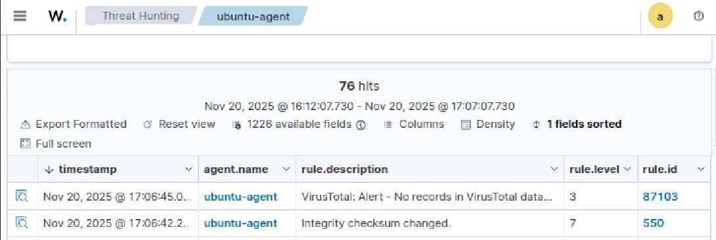

This screenshot provides context for the file's initial state and prior classification. It shows the detailed document for the original creation of benignfile.txt. Crucially, it confirms that the file identified as nonmalicious:

- data.virustotal.malicious: 0: This flag confirms that the content of the file was classified as harmless by the VirusTotal integration.
- Significance: By referencing this initial benign status, the subsequent Level 7 "Integrity checksum changed" alert becomes more critical, highlighting that an otherwise known-good file has been tampered with, which is a key indicator of potential compromise.

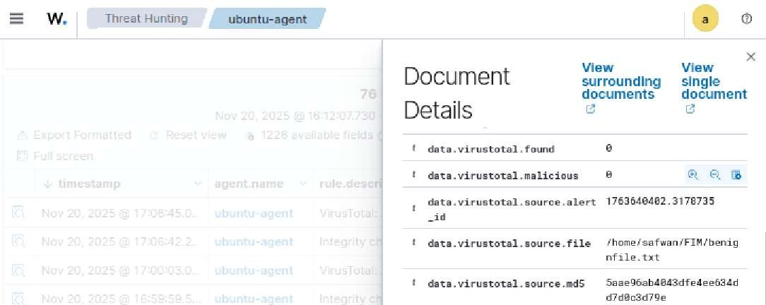

File Name | File Type | VirusTotal Detection | Alert Severity
Benign File  (benignfile.txt) | New Text File | No records found in VT. | Level 3 (Low)
Known Malicious Hash (knownmalware.txt) | New Text File  (containing hash) | No detection / Not malicious. | Level 3 (Low)
Modified File (benignfile.txt modified) | Existing File Change | Integrity checksum changed. | Level 7 (Medium)

Task 4.2: Alert Analysis

This section details my in-depth analysis of the Wazuh alert generated by the EICAR test file, leveraging the VirusTotal integration. I located the full alert in the dashboard and extracted key information, including the detection ratio and the direct link to the VirusTotal report, which provided a wealth of threat intelligence.

This screenshot shows the initial view of the Wazuh dashboard where I located the specific alert triggered by the EICAR test file. This is the entry point for investigating the detection.

- "VirusTotal. Alert": The prominent alert title, indicating the source of the detection.
- /home/safwan/FIM/eicar.com: The path to the malicious file that was detected.
- "58 engines": This number immediately tells me that 58 different antivirus engines on VirusTotal flagged this file.
- 87105: The unique alert ID, which helps in tracking and referencing this specific incident.
- My Action: I clicked on this alert entry to view its full details, as shown in the subsequent screenshots.

After clicking on the alert, this screenshot displays the "Document Details" pane, which provides a comprehensive breakdown of the alert's metadata. This is where I found explicit confirmation of the VirusTotal integration and crucial details about its findings.

- agent.id: 002, agent.name: ubuntu-agent: Identifies the specific Wazuh agent that reported the event.
- data.integration: virustotal: Confirms that this alert originated from our configured VirusTotal integration.
- data.virustotal.found: 1: Indicates that VirusTotal did find detections for the submitted file. • data.virustotal.malicious: 1: Further confirms that the file was classified as malicious by VirusTotal.
- data.virustotal.permalink: This is the direct URL to the full VirusTotal report for this EICAR file. I will use this link to access the detailed analysis.
- My Analysis: From these fields, I can quickly confirm that the integration worked perfectly, and VirusTotal positively identified the EICAR file.

This screenshot is the direct summary report from the VirusTotal website, accessed via the permalink provided in the Wazuh alert. It clearly shows the aggregated detection results for the EICAR file.
- VirusTotal Detection Ratio: The prominent "58/66" in the center indicates that 58 out of 66 antivirus engines detected the EICAR test file. This directly answers the requirement to identify the detection ratio and confirms the widespread recognition of the EICAR string as a threat.

- Information Provided by VirusTotal (Summary Tab):
  - Community Score: A score of "224" indicates the community's assessment of the file.
  - File Hash: The long hexadecimal string (131f95...) is the unique hash of the file that was analyzed.
  - File Name: eicar.txt (or eicar.com in our case, as the hash is consistent) confirms the analyzed file.
  - Scan Date: 2025-11-19 10:17:26 UTC shows precisely when VirusTotal performed the scan.

- My Analysis: This summary page provides immediate, high-level intelligence: how many vendors flag the file and essential metadata like its hash and scan date. This is typically the first place I look on VirusTotal to gauge the severity and recognition of a detected artifact.

This screenshot provides a more granular view within the VirusTotal report, detailing which specific security vendors detected the EICAR file and what name they assigned to it.

- Engine-Specific Detections: Each listed entry shows a different security vendor (e.g., AhnLab, Alibaba, Avast) and their specific detection signature for the EICAR test file (e.g., Virus/EICAR_Test_File, EICAR-Test-NOT Virus!!!).

- My Analysis: This detailed list helps me understand the consistency and naming conventions across various antivirus products. For a real threat, this information could be used to correlate findings with internal security tools or to understand potential gaps if certain engines didn't detect it.

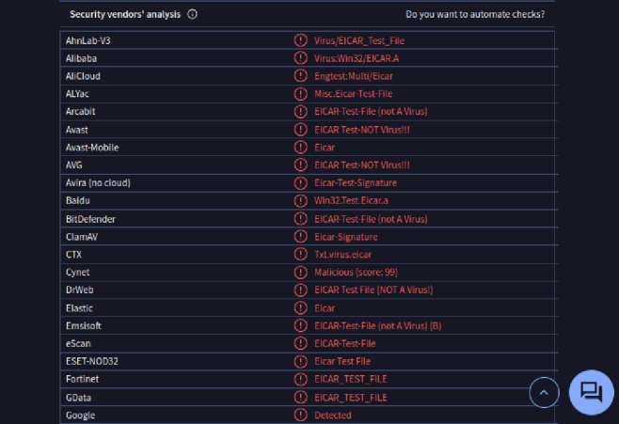

Phase 5: Incident Response Plan

Objective:
To outline a structured, step-by-step incident response workflow for the detection, verification, and automated enrichment of suspicious files leveraging Wazuh's File Integrity Monitoring (FIM) and VirusTotal integration. This plan details the actions from initial detection to the Security Operations Center (SOC) team's recommended response.

- Detection of Suspicious Files by Wazuh FIM:
This phase describes the proactive monitoring by Wazuh's File Integrity Monitoring (FIM) module to identify unauthorized or suspicious file changes within critical system directories.

  - Continuous Monitoring: Wazuh's FIM agents are configured to continuously monitor designated critical directories (e.g., /home/safwan/FIM/) for any unauthorized modifications, creations, or deletions.

  - Event Trigger: Upon detection of a file event (such as the creation or modification of eicar.com), the Wazuh agent immediately generates and forwards an alert to the Wazuh Manager.

  - Initial Alert Data: The generated alert comprehensively includes: ➢ The full file path (/home/safwan/FIM/eicar.com).
      - The reporting agent's name (Ubuntu-agent).
      - The precise timestamp of the event.
      - An initial severity and descriptive message of the file change.
      - Crucially, Wazuh automatically computes the cryptographic hash (e.g., MD5, SHA1, SHA256) of the detected file. This hash is then prepared for submission to the configured external integration.

- Automated VirusTotal Integration and Threat Intelligence Enrichment
Following initial detection, Wazuh's integrated capabilities automatically query VirusTotal to enrich the alert with global threat intelligence.

  - API Call Initiation: The VirusTotal integration, as defined within the <integration> block of ossec.conf, automatically intercepts the file hash from the detected event. It then securely transmits this hash to the VirusTotal API.

  - VirusTotal Response & Data Enrichment: Upon receiving the query, VirusTotal processes the hash against its vast database of over 60 antivirus engines and community intelligence. It returns comprehensive results, which Wazuh then incorporates into the alert:
      - Detection Ratio: A clear indication of how many antivirus engines flagged the file (e.g., 58/66 engines).
      - Vendor-Specific Labels: Detailed names or classifications assigned by individual antivirus vendors (e.g., BitDefender: "EICAR-Test-File (not a virus)").
      - Persistent Report URL: A unique data.virustotal.permalink providing a direct link to the full, comprehensive VirusTotal analysis report for further deepdive investigation.

  - Benefit: This automated process ensures near real-time threat intelligence enrichment, eliminating the need for manual hash lookups and accelerating the initial investigation phase.

- Malware Detection Threshold and Initial Classification
This stage defines the automated criteria for flagging a file as potentially malicious based on VirusTotal's response and guides initial classification.

  - Dynamic Alerting: If the number of antivirus engines detecting the file exceeds a predefined Security Operations Center (SOC) threshold (e.g., greater than 10 engines), Wazuh automatically elevates the alert's severity and flags the file as potentially malicious. This threshold is adjustable based on organizational risk tolerance.

  - SOC Trigger: An alert exceeding this threshold immediately triggers a requirement for the SOC team to investigate further and initiate appropriate incident response actions.

  - EICAR Test Case: In the context of our EICAR test file:
    - The file was detected by a very high number of engines (e.g., 58/66), significantly surpassing the threshold.
    - However, knowing that EICAR is a standard, harmless test file, this alert is classified as a verified test incident rather than an actual security breach. This distinction is crucial for accurate incident management and avoiding false positives in production environments.

- Recommended Actions for the SOC Team
This section outlines the prescribed actions for the SOC team when confronted with a VirusTotal-enriched alert of a suspicious file.

  - Alert Verification:
    - Access the Wazuh dashboard to view the newly generated alert.
    - Confirm the data.integration: virustotal field to ensure the enrichment process was successful.

  - Threat Intelligence Review:
    - Utilize the provided data.virustotal.permalink to navigate directly to the VirusTotal report.
    - Analyze the detection ratio to understand the prevalence and recognition of the threat.
    - Review vendor-specific labels for detailed classifications and potential false positives (as with EICAR).

  - Contextual Severity Confirmation:
    - Evaluate the overall context: For a high detection count (e.g., 58/66 engines) on a file known to be harmless (like EICAR), confirm that it is indeed a recognized test file and not genuine malware. This step is critical for avoiding unnecessary escalation during testing.
    - For actual malware, a high detection count confirms its malicious nature.

  - Incident Documentation:
    - Document the alert thoroughly, noting all findings and the classification (e.g., "EICAR Test Incident - Verified Functionality").
    - For actual threats, this documentation would form part of the official incident report.

  - Alert Resolution:
    - Based on the analysis and documentation, close the alert in the Wazuh dashboard, marking it as resolved (e.g., "Closed - Verified Test" or "Closed - Remediated" for real threats).

  - Escalation (for actual threats): If the file is confirmed as genuine malware, the SOC team would initiate further incident response procedures, including:
    - Containment: Isolate affected systems or block the malicious file.
    - Eradication: Remove the malware from the environment.
    - Recovery: Restore affected systems to normal operation.
    - Lessons Learned: Update security policies and controls to prevent future occurrences

